KIW-L24C567B331
Software Upgrade Guideline
软件升级指导书

Prepared by | Divya S Moger | Date | 2016-06-24
Reviewed by | Gowrinath I V R 70361 | Date | 2016-06-24
Approved by | Ramkumar Chalasani 70320 | Date | 2016-06-24



Huawei Technologies Co., Ltd.
All rights reserved
Contents
Contents 2
1 版本介绍Version introduction 3
1.1 历史版本信息，以下版本可以升级The following versions can be upgraded. 3
1.2 升级包Upgrade package 3
2 升级环境要求Upgrade requirements 3
2.1 检查当前升级环境Check current upgrade environment 3
3 升级介绍Upgrade introduction 4
4 升级操作Upgrade operations 4
4.1 正常升级Normal upgrade 4
4.2 Force upgrade 6
4.3 例外Exceptions 7
5 升级验证Upgrade validate 7
5.1 检查版本号Check the version 7

版本介绍Version introduction

历史版本信息，以下版本可以升级The following versions can be upgraded.
Versions can be upgraded
KIW-L24C567B151

升级包Upgrade package
Upgrade package升级包 | Info 信息
Main package主要包 | \dload\UPDATE.APP
Vendor package供应商包装 | \CUSTOMIZED_HW_USA\UPDATE.APP
Upgrade tools升级工具 | Micro SD card

升级环境要求Upgrade requirements

检查当前升级环境Check current upgrade environment
- 确认MicroSD卡空间足够且读写正常。To make sure that the Micro SD card is available with enough free space and can be read and write.
备注Notes: 用4G或者更大的MicroSD卡。建议使用Sandisk/Kingstone/Kingmax。A Micro SD card of 4GB or more should be available. It is recommended that The Micro SD card is made by Sandisk, Kingstone, or Kingmax.
- 确保进行升级时电池电量充足。建议在所述电池的功率是30％以上。To make sure that the power of the battery is enough to run the upgrade process. It is recommended that the power of the battery is more than 30%.
- 升级操作会擦出用户数据，如果有重要数据请先备份。Upgrade operations will erase all user data. You should backup all important data before upgrade.
- 如果主包的路径是在第二章1.2的.zip文件，你应该解压.zip文件首先，走出UPDATE.APP做升级操作。If the path of main package is a .zip file in chapter 1.2, you should unzip the .zip file firstly, and get out UPDATE.APP to do upgrade operation.

升级介绍Upgrade introduction
有两种升级方法：正常升级和强制升级。There are two methods to upgrade: normal upgrade and force upgrade.
正常升级需启动手机并进入设置模块。强制升级常用于手机无法启动或无法进入待机界面的场景。Normal upgrade needs to start the handset and enter the System Update module. Force upgrade is just used when the handset can’t boot up or can’t enter the idle screen.

升级操作Upgrade operations

正常升级Normal upgrade
- 格式化MicroSD卡(可选)。Format the Micro SD card (This operation is optional).
- 复制软件：主包UPDATE.APP到一个指定的目录 dload。Copy the Software: main package UPDATE.APP to a directory named dload.
- 节描述的大包目录下整个dload目录(包含UPDATE.APP)拷贝到MicroSD卡根目录。Copy the entire dload folder (with UPDATE.APP in it) to the root directory of the Micro SD card.
- 将MicroSD卡插入手机并开机。进入桌面后选择 Settings->All-> Updater->Menu ->Local update->Confirm->Upgrade 进行升级，可参考下图。Insert the Micro SD card into the handset and power on. After entering the home screen, To find settings application, press Settings->All->Updater->Menu->Local update->Full Package:Update.app->Install to start the upgrade. Please reference to the following pictures :
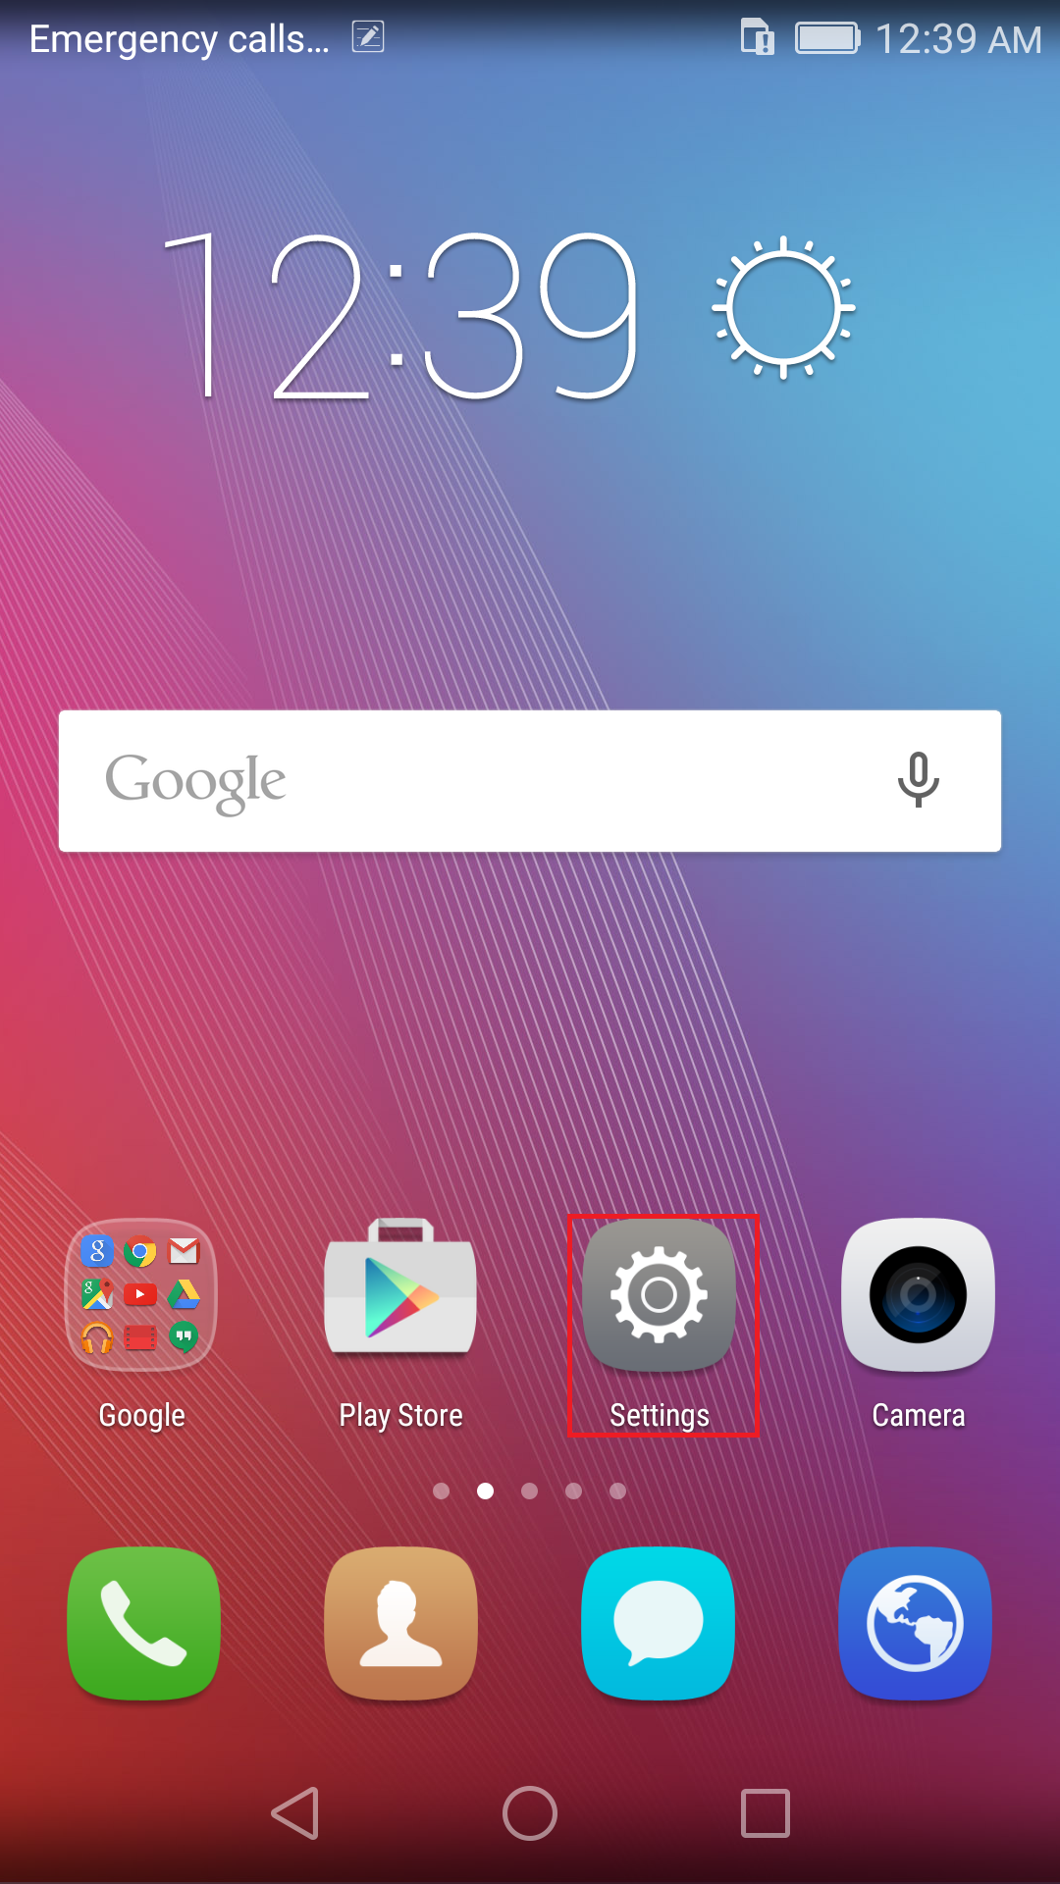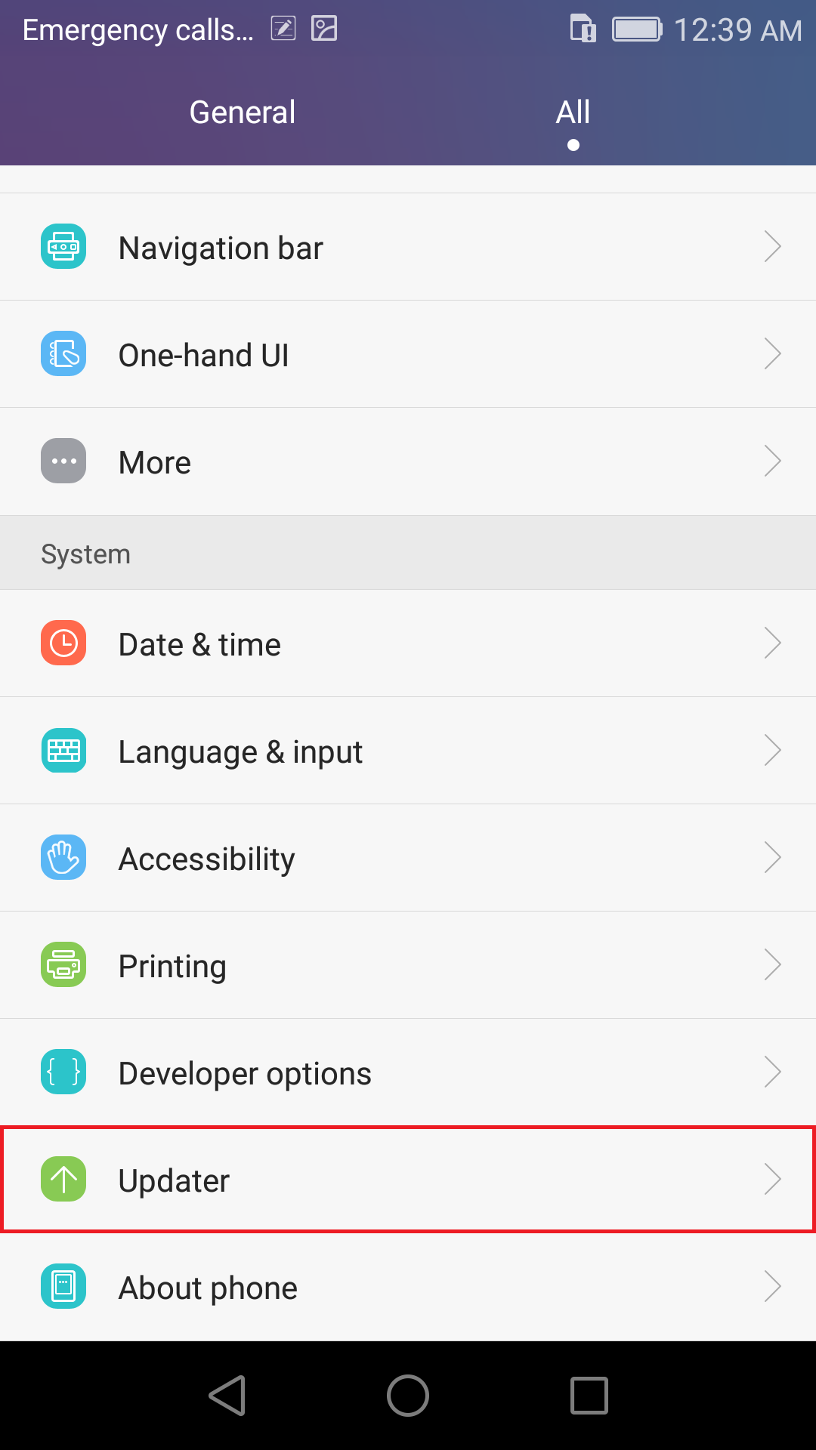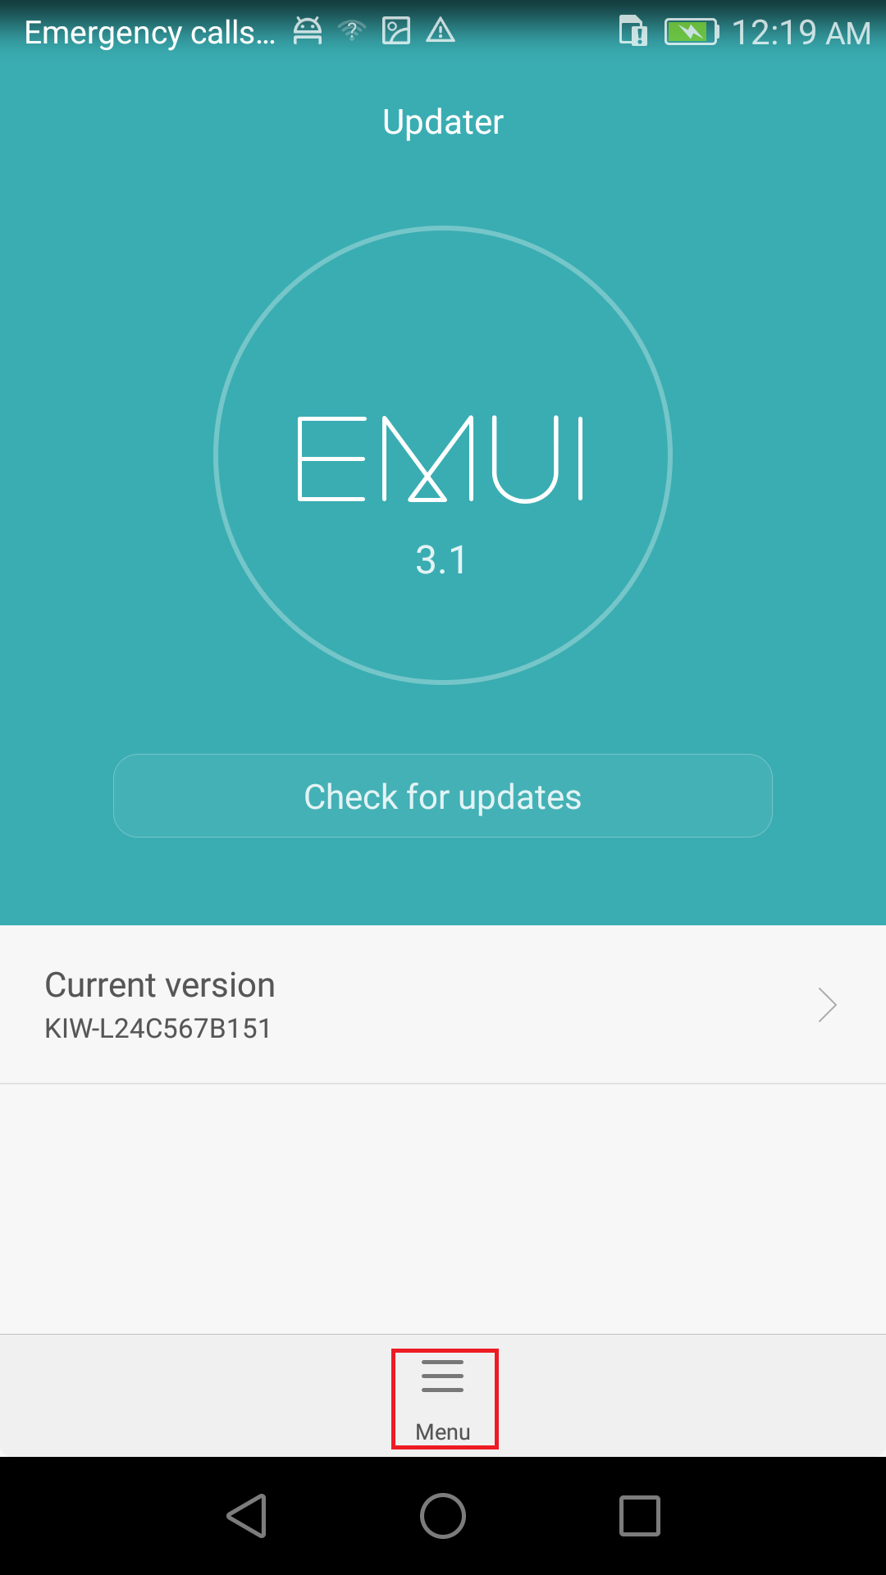

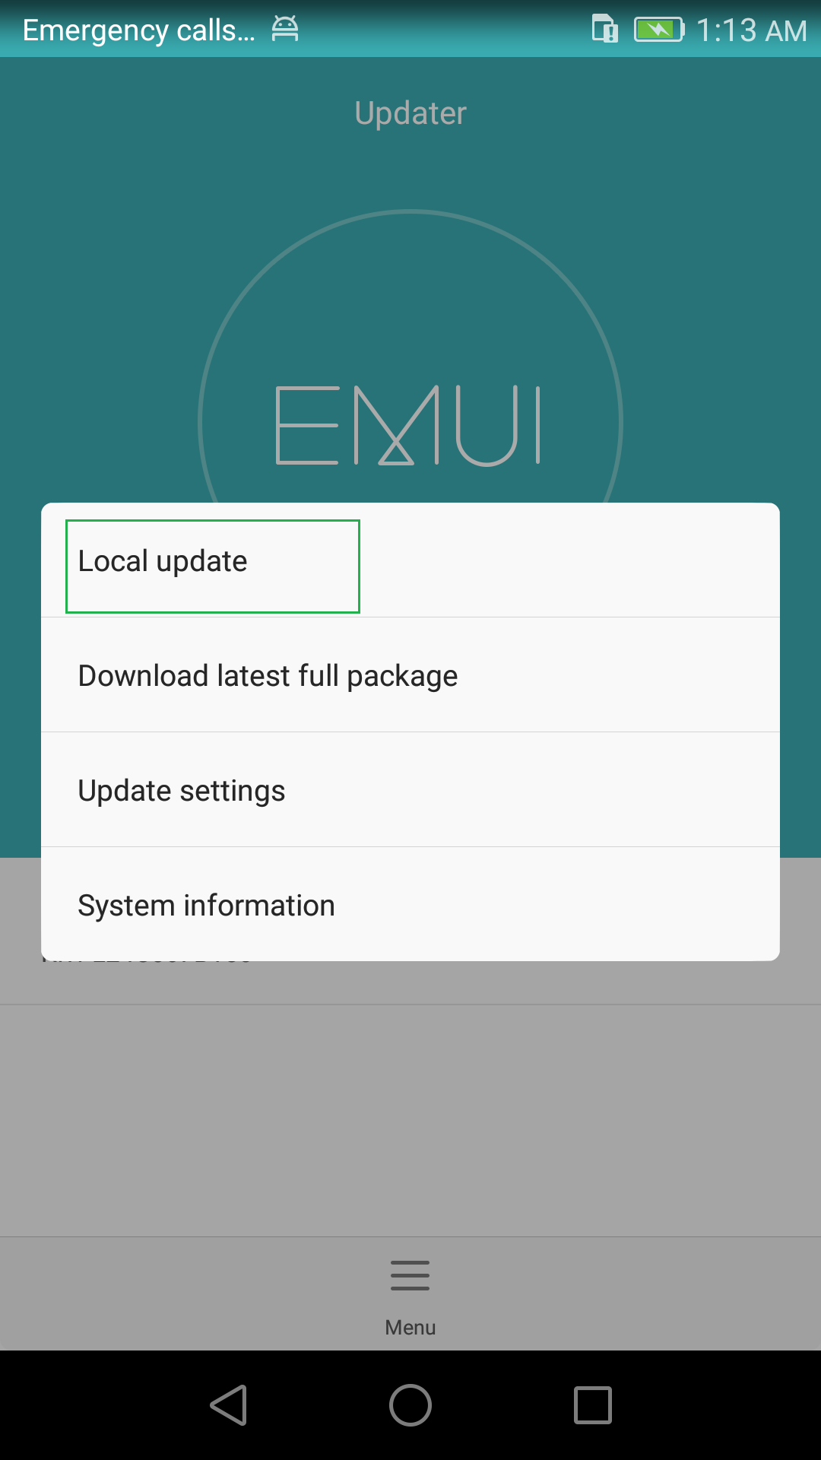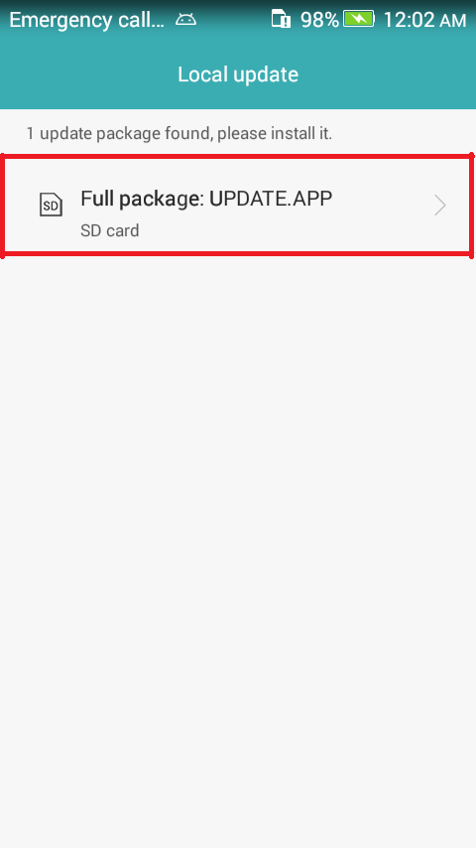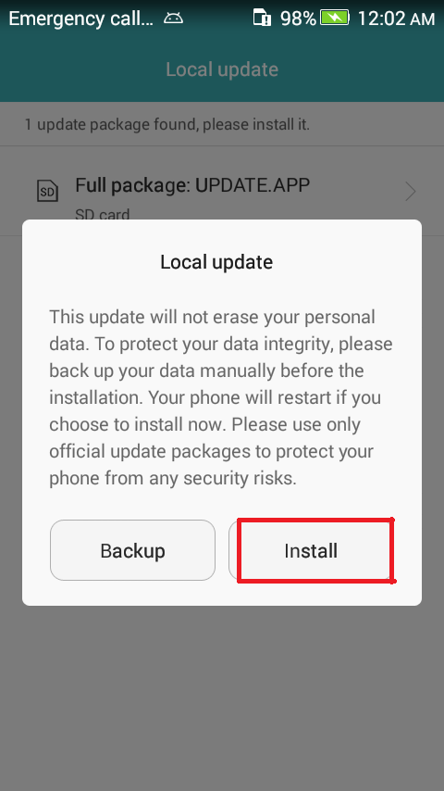
- 进度条走完后手机会重启。若没重启则需手动取下电池。When the progress bar stop, the phone will restart automatically.
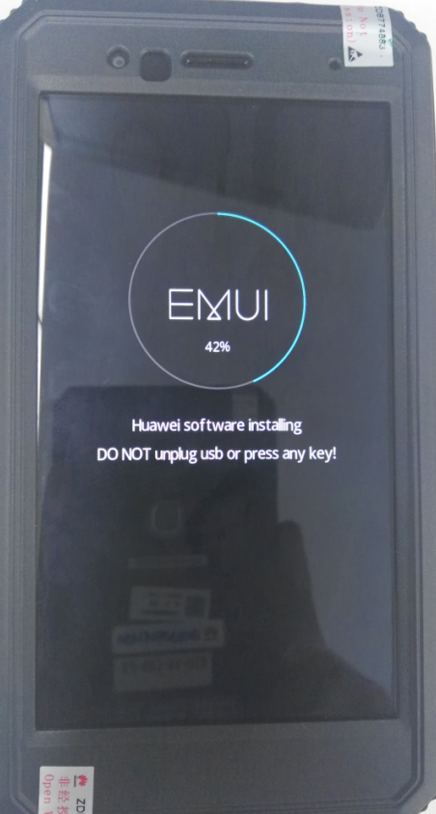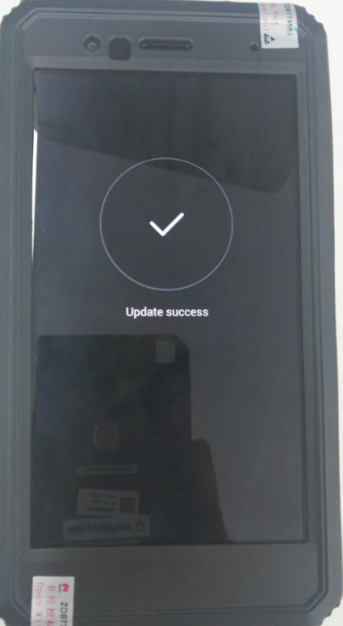
- 复制软件：(产线请忽略此操作)删除SD卡上的 dload目录，的vendor包的整体拷贝SD卡根目录，然后执行上述步骤2-5。Please copy the Software: vendor package UPDATE.APP to a directory named dload. Then execute Step 2 – Step 5 repeatedly. This step is needed only when the version is upgraded by test member.

Force upgrade
- 格式化MicroSD卡(可选)。Format the Micro SD card (This operation is optional).
- 复制软件：主包UPDATE.APP到一个指定的目录dload。Copy the Software: main package to a directory named dload.
- 节描述的大包目录下整个dload目录(包含UPDATE.APP)拷贝到MicroSD卡根目录。Copy the entire dload folder (with UPDATE.APP in it) to the root directory of the Micro SD card.
- 在手机关机状态下，插入MicroSD卡，同时按住音量上键+音量下键+电源键，手机会启动并进入升级模式。Make sure your handset is power off. Insert the Micro SD card into the handset. Press the VOLUME UP and VOLUME DOWN key, and then press the POWER key to power on the phone and enter the Software Upgrade Mode.
- 进度条结束后，手机会重启。若手机未重启，需要手动拔下电池。When the progress bar stop, the phone will restart automatically.
- 复制软件：(产线请忽略此操作)删除SD卡上的 dload目录，的vendor包的整体拷贝SD卡根目录，然后执行上述步骤2-5。Please copy the Software: vendor package UPDATE.APP to a directory named dload. Then Execute Step 2 – Step 5 repeatedly. This step is needed only when the version is upgraded by test member.

例外Exceptions
如果升级失败，屏幕上会显示如下的故障原因。例如，故障在图中示出，有一个软件版本控制问题，应首先升级通过研发提供一个传输包。If upgrading fail, the screen shows as below with the failure cause. Please contact R&D (KIW-L24 TEAM) for the solution.
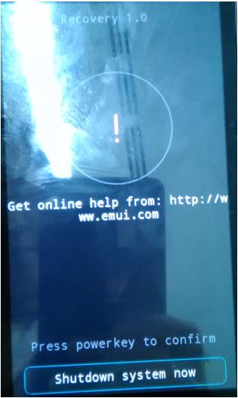

升级验证Upgrade validate

检查版本号Check the version
      - 如图检查版本号Build number By step: Settings->About phone->Build number, to check the version is correct or not.
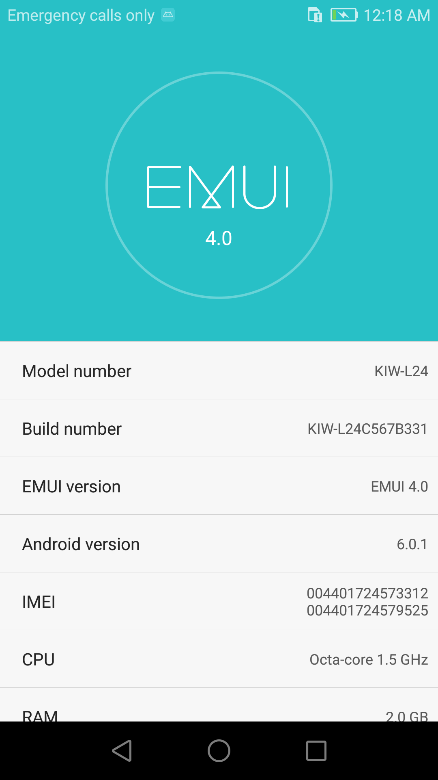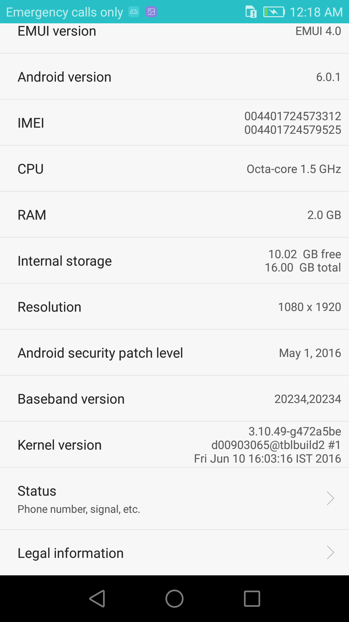

Build number: KIW-L24C567B331

